**PlayDownloader User Manual**



# **What is PlayDownloader?**

[PlayDownloader](https://playdownloader.com) is a powerful tool designed to help you efficiently manage downloads of YouTube and TikTok videos. Our software supports a variety of formats including MP4 and MP3, making it easy to save your favorite videos and music offline.

# **Table of Contents**

**What is PlayDownloader? 1**

**Table of Contents 2**

Introduction 3

System Requirements 3

Installation 4

Windows 4

macOS 4

Linux 4

Getting Started 5

Launching the Application 5

User Interface Overview 6

Home Page 6

Playlists Page 6

Search Page 7

Settings Page 7

Help Page 8

About Page 8

Downloading Videos 9

Downloading from YouTube 9

Downloading YouTube Playlists 9

Downloading from TikTok 9

Managing Downloads 9

Pausing, Resuming, and Stopping Downloads 9

Auto-Resume Functionality 9

Browser Extension 10

Features 10

Download Button 10

Installation 10

Chrome: 11

Firefox: 11

Safari: 11

Troubleshooting 12

Common Issues and Solutions 12

Manage License or Subscription 12

Contact Support 12

# **Introduction**

PlayDownloader is a powerful tool designed to help you efficiently manage downloads of YouTube and TikTok videos. Our software supports a variety of formats including MP4 and MP3, making it easy to save your favorite videos and music offline.

With PlayDownloader, you can pause, resume, and stop downloads at your convenience. Our auto-resume feature ensures that your downloads are never interrupted, even if they are accidentally deleted or interrupted.

Download entire YouTube playlists with a single click, and use our built-in search function to easily find your downloaded content. PlayDownloader also includes automatic updates to ensure you always have access to the latest features and improvements.

# **System Requirements**

Before installing PlayDownloader, please make sure your computer meets the following requirements:

* Operating System: Windows 7 or higher, macOS 10.10 or higher, Linux
* Processor: Intel Pentium 4 or later
* RAM: 1 GB minimum
* Disk Space: 200 MB of free space

# 

# **Installation**

To install PlayDownloader, please follow these steps:

## **Windows**

1. Download the installer from the [PlayDownloader](https://playdownloader.com/download) website.
2. Run the installer and follow the on-screen instructions.
3. Once installed, launch PlayDownloader from the Start menu.

## **macOS**

1. Download the DMG file from the [PlayDownloader](https://playdownloader.com/download) website.
2. Open the DMG file and drag the PlayDownloader app to the Applications folder.
3. Launch PlayDownloader from the Applications folder.

## **Linux**

1. Download the appropriate package from the [PlayDownloader](https://playdownloader.com/download) website for your distribution (DEB for Debian/Ubuntu, RPM for Fedora/RedHat).
2. Open a terminal and run the following command:

* For DEB: *sudo dpkg -i playdownloader.deb*
* For RPM: *sudo rpm -i playdownloader.rpm*

1. Launch PlayDownloader from the applications menu.

# 

# **Getting Started**

## Launching the Application

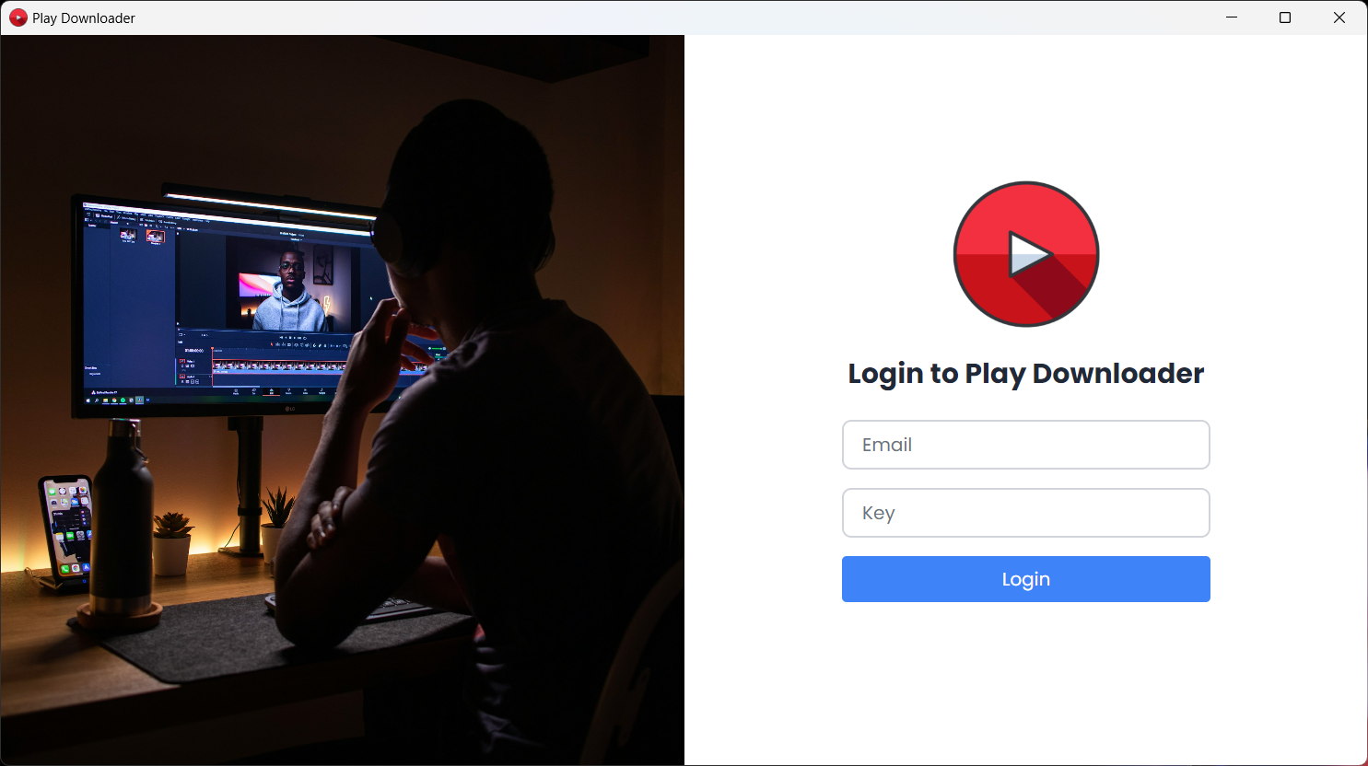

1. **Register and Activate:** Before launching PlayDownloader, you need to register and activate your plan.

* Visit the [PlayDownloader](https://playdownloader.com/) website and sign up with your email.
* Follow the instructions in the activation email to activate your plan.

1. **Login with Key:** Once your plan is activated, you will receive a login key.

* Open PlayDownloader by clicking on the application icon on your desktop or applications menu.
* Enter your login key to access the software.

## 

## 

## **User Interface Overview**

The PlayDownloader user interface is designed to be intuitive and easy to use. Here's a brief overview of the different parts of the interface:

### **Home Page**

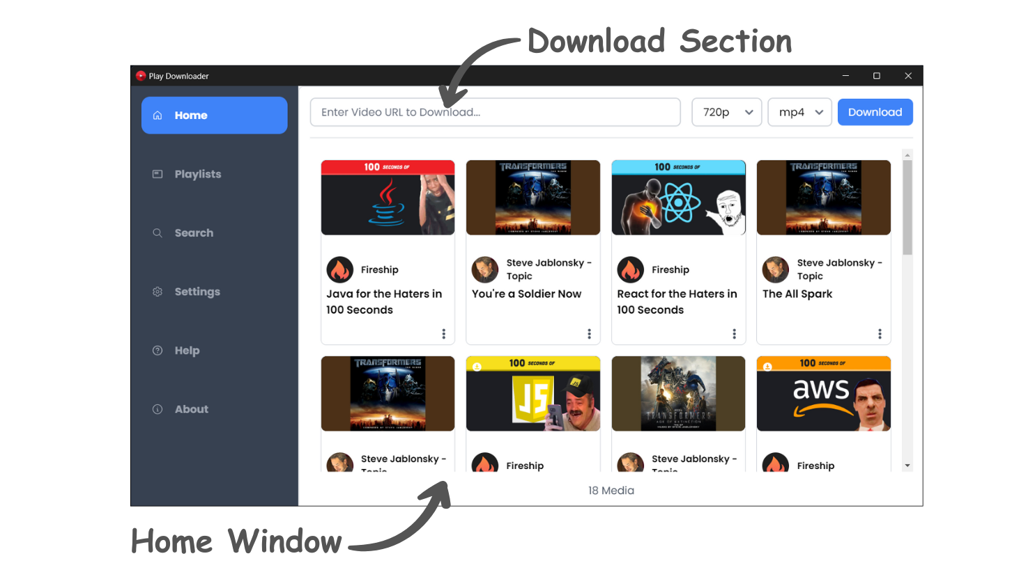

* Displays the recent download media.
* Navigation Bar: Includes links to Home, Playlists, Search, Settings, Help and About.
* Download Section: Area to paste video URLs and start downloads.

### **Playlists Page**

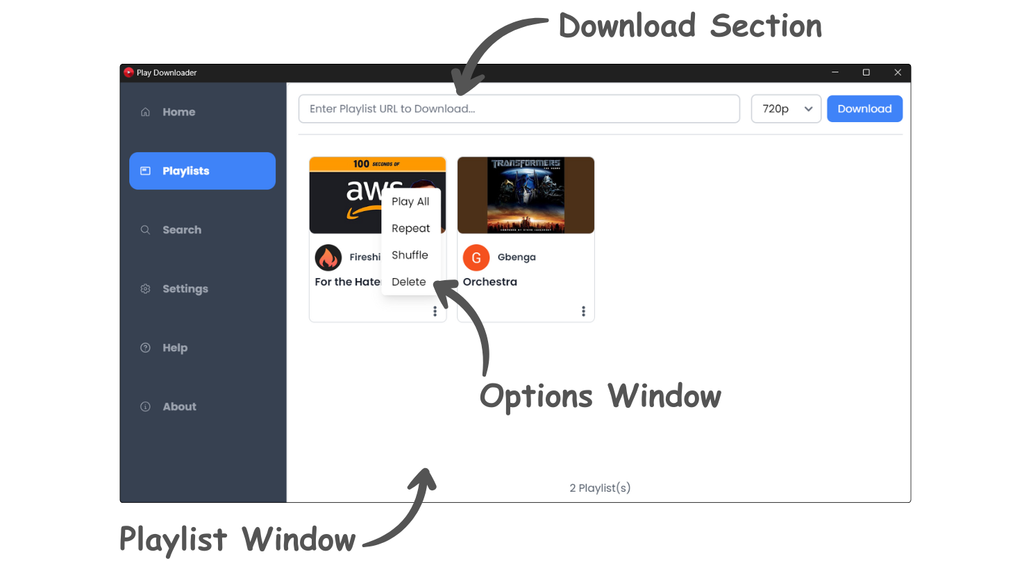

* Shows downloaded playlists and allows managing them.
* Download Section: Area to paste playlist URLs and start downloads.

### **Search Page**

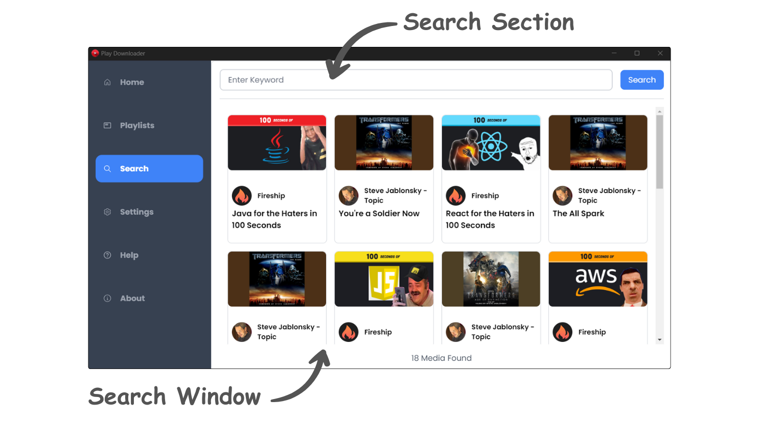

* Search for any downloaded media by using a name or any keyword.

### **Settings Page**

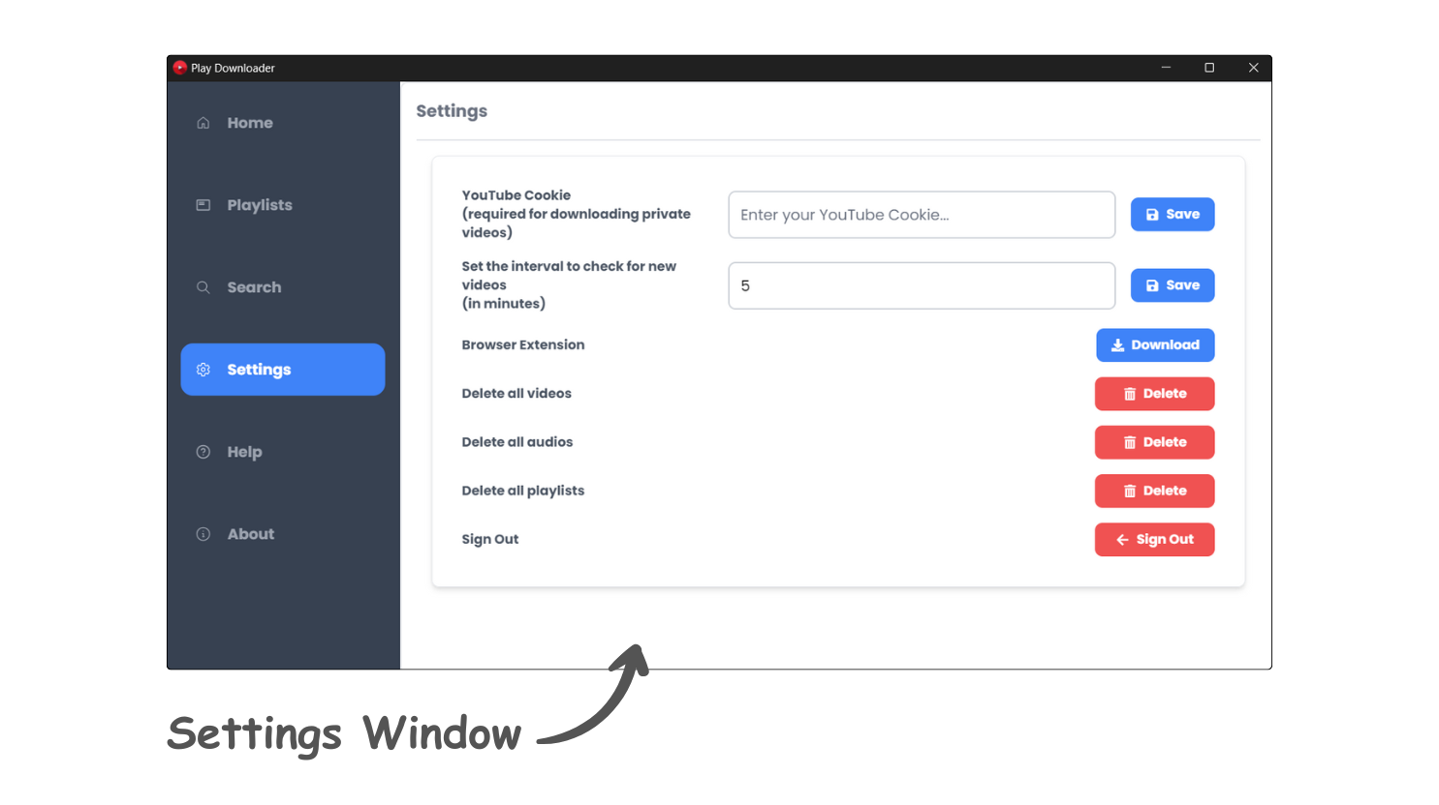

* Configure application preferences.
* Users can enter YouTube cookies to download private videos.
* There is a field to add an interval time to check if a downloaded playlist has any updated videos; if so, they will be automatically downloaded.
* A button to download the browser extension, redirecting to the extension folder for installation.
* Additional buttons include deleting all videos, playlists, audios, and signing out.

### **Help Page**

### 

* Access help documentation and FAQs.

### **About Page**

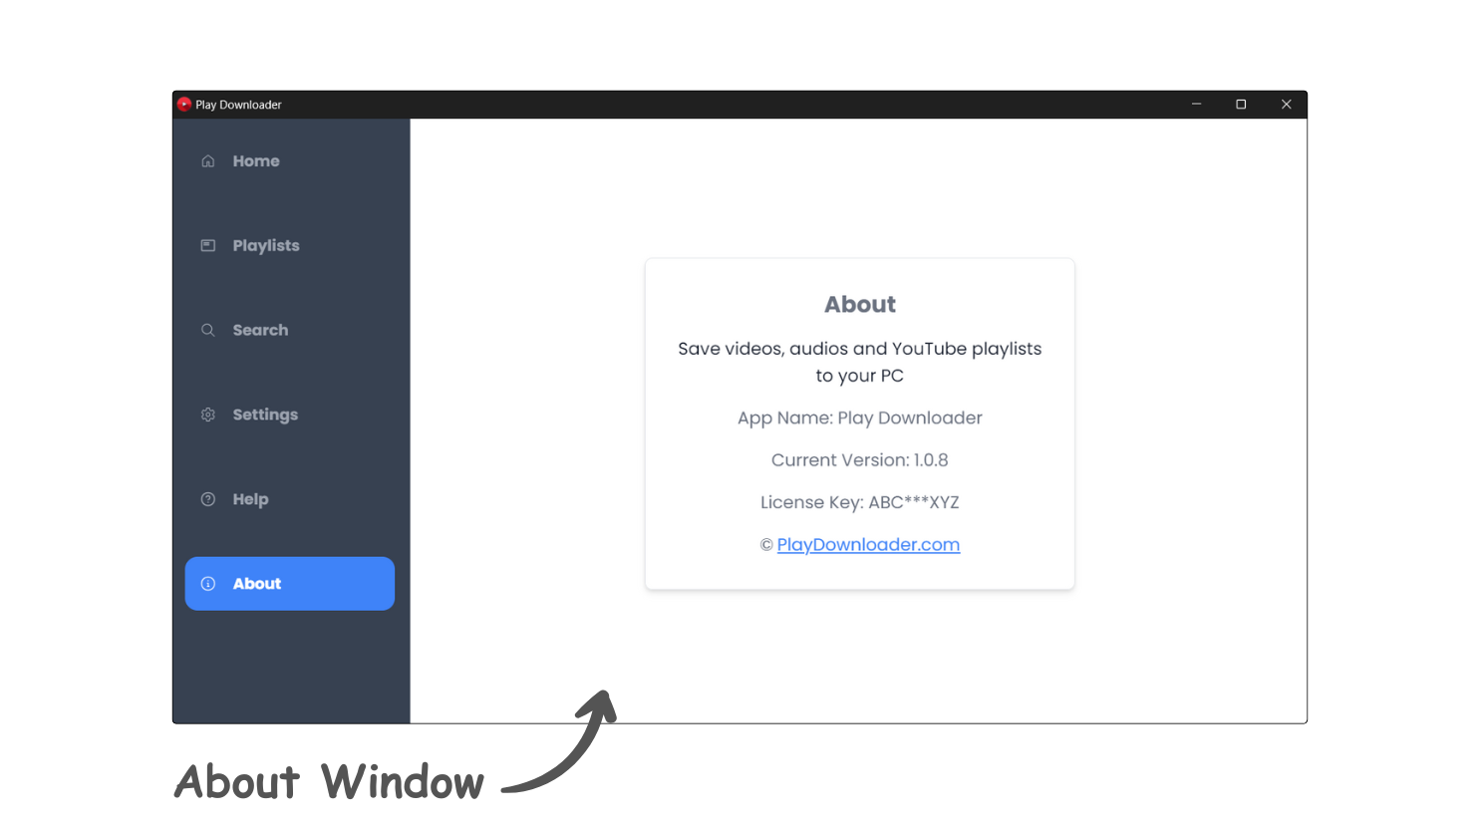

* View information about the application, version details, and credits.

# **Downloading Videos**

## **Downloading from YouTube**

1. Copy the URL of the YouTube video you want to download.
2. Paste the URL into the Home Download Section of PlayDownloader.
3. Select the desired Quality (720p, 1080p etc.).
4. Select the desired format (MP4, MP3).
5. Click on the "Download" button.

## **Downloading YouTube Playlists**

1. Copy the URL of the YouTube playlist you want to download.
2. Paste the URL into the Download Section of PlayDownloader.
3. Select the desired Quality for all videos(720p, 1080p etc.).
4. Click on the "Download" button.

## **Downloading from TikTok**

1. Copy the URL of the TikTok video you want to download.
2. Paste the URL into the Home Download Section of PlayDownloader.
3. Select the desired Quality (720p, 1080p etc.).
4. Select the desired format (MP4, MP3).
5. Click on the "Download" button.

# **Managing Downloads**

## **Pausing, Resuming, and Stopping Downloads**

* Pause: Click the "Pause" icon button top of the downloading video.
* Resume: Click the "Resume" icon button top of the downloading video for continue downloading.
* Stop: Click the "Stop" icon button to cancel the download.

## **Auto-Resume Functionality**

* If a download is interrupted, PlayDownloader will automatically resume the download when the connection is restored.

# **Browser Extension**

The PlayDownloader browser extension enhances the functionality of the software by integrating directly with your web browser. Here’s how to use it:

## **Features**

* Download YouTube Cookies: This button allows you to download your YouTube cookies to enable downloading of private videos.
* Copy Cookies: Use this button to copy your YouTube cookies to the clipboard for easy pasting into the PlayDownloader settings.
* Refresh Cookies: Refresh your YouTube cookies to ensure they are up-to-date.

## **Download Button**

* Download Current Video: When you navigate to a YouTube video, the extension adds a "Download" button. Clicking this button will fetch the URL of the current video and send it to the PlayDownloader software, which will then start downloading the video.

## **Installation**

1. Go to the Settings in PlayDownloader.
2. Click on the "Browser Extension" button.
3. You will be redirected to the extension folder. Install the extension in your browser.
4. Follow the instructions to set up and activate the extension.

### 

### **Chrome:**

1. Open Google Chrome browser.
2. Enter ***chrome://extensions*** into the address bar and click the "Enter" button on your keyboard.
3. Click on the "Load Unpacked Extension" button.
4. Select the appropriate folder for the PlayDownloader Chrome extension.

### **Firefox:**

1. Open Firefox browser.
2. Enter ***about:debugging*** into the address bar and click the "Enter" button on your keyboard.
3. Click on the "Load Temporary Add-on" button.
4. Select the appropriate file from the PlayDownloader Firefox extension folder.

### **Safari:**

1. Open Safari browser.
2. Go to the menu "Develop -> Show Extension Builder" (If there is no Develop menu, open Safari "Preferences -> Advanced", and check "Show Develop menu in menu bar").
3. In the Extension Builder window, click the "+" at the left-bottom of the window, then click "Add Extension".
4. Select the appropriate folder for the PlayDownloader Safari extension.
5. Now your extension will show at the left panel of the Extension Builder. You can click the "Install" button to install it.

# **Troubleshooting**

## **Common Issues and Solutions**

If you encounter any issues while using PlayDownloader, please refer to this section for troubleshooting advice. If the issue persists, please contact support (see next section).

* Download Fails: Check your internet connection and ensure the video URL is correct.
* App Crashes: Restart the app and try again. If the issue persists, reinstall the app.
* Slow Downloads: Check your internet speed and try downloading during off-peak hours.

# **Manage License or Subscription**

If you need to manage your license or subscription with PlayDownloader, please visit.

* Website: [PlayDownloader License & Subscription](https://playdownloader.com/manage.html)

# **Contact Support**

If you need further assistance with PlayDownloader, please contact our support team at.

* Email: [support@playdownloader.com](mailto:support@playdownloader.com)
* Website: [PlayDownloader Support](https://playdownloader.com/contact.html)